Problem set 8

**Exercise 1: Business Simulation in Excel**

Suppose that your company is planning marketing for the new product. Your goal is to simulate the possible marketing costs under the condition that the probability of profit will not fall under 0.75. Use the business data from the Excel file sim8_bs.xlsx (Business Simulation).



The solution is provided inside the Excel file.

**Exercise 2: Roll the matchbox (Excel)**

Use the Excel file Monte Carlo to simulate the roll of a matchbox. Set your probability for every site of a box and run the simulation 1000 times. Calculate simulation mean, variance, and standard deviation. Plot simulated frequencies.

The solution is provided inside the Excel file.

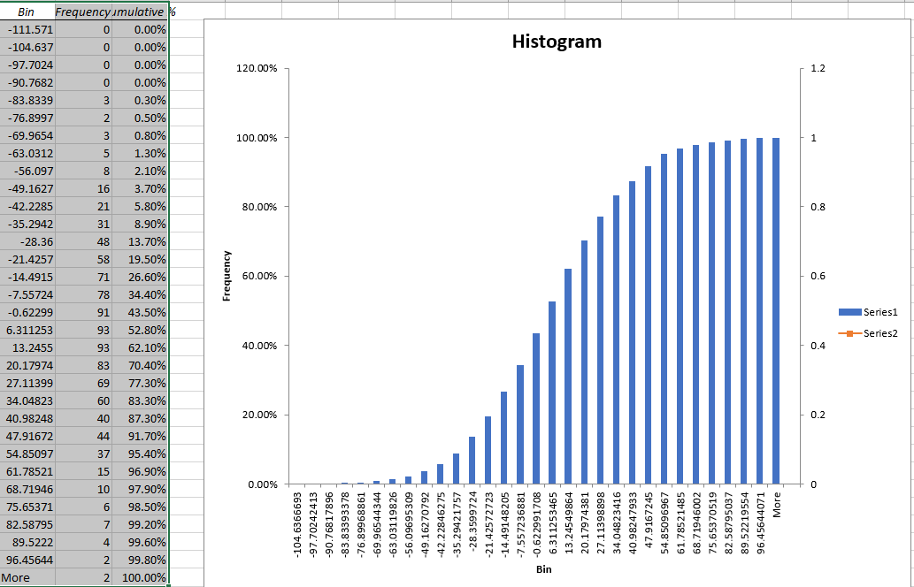

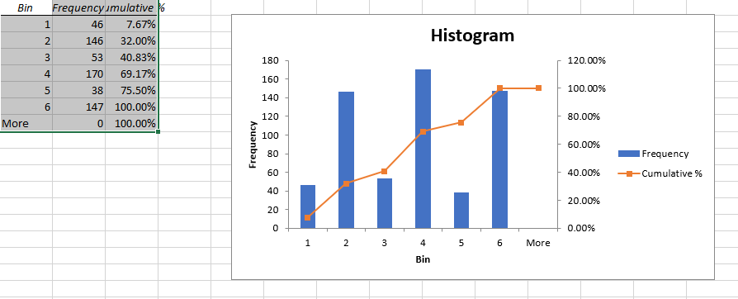

# Exercise 3: Estimating π (in R)

Write a program to estimate π. Simulate first the random variable Z:



Use Monte Carlo integration for your estimation.

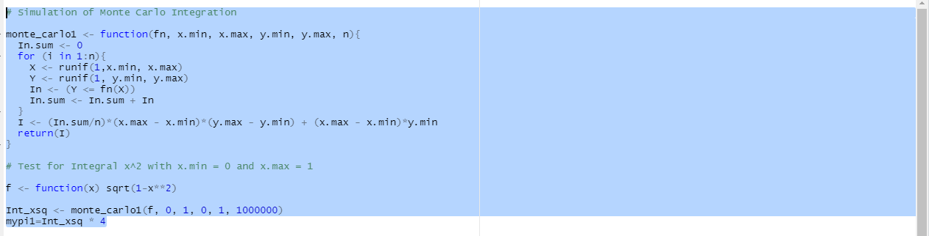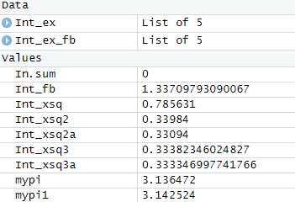

# Exercise 4: Beta Function with Monte Carlo integral

Write the program to estimate the Beta function B(z,w) for z = 0.5 and w = 2 using Monte Carlo integration and compare your results with exact value of integral.



